DATA ANALYTICS WITH TABLEAU

ASSIGNMENT-02

Name: DARAM LOWKYA Mail: [daramlowkya@gmail.com](mailto:daramlowkya@gmail.com)

College: Gudlavalleru Engineering College RollNo: 22481A5413

1.DONUT CHART

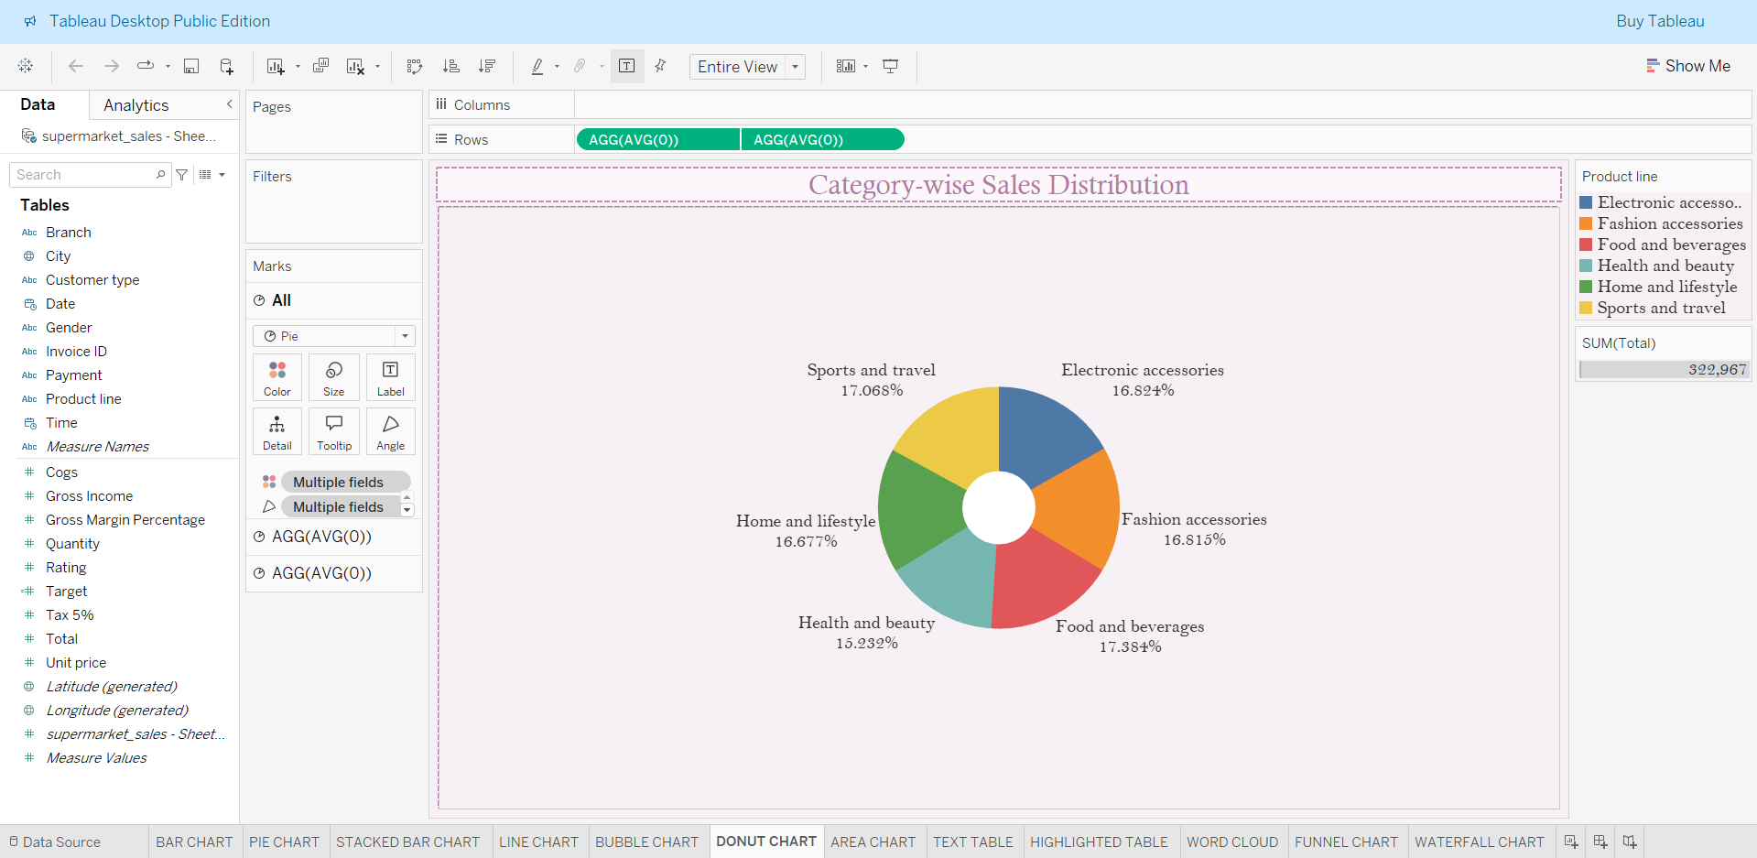

2.AREA CHART

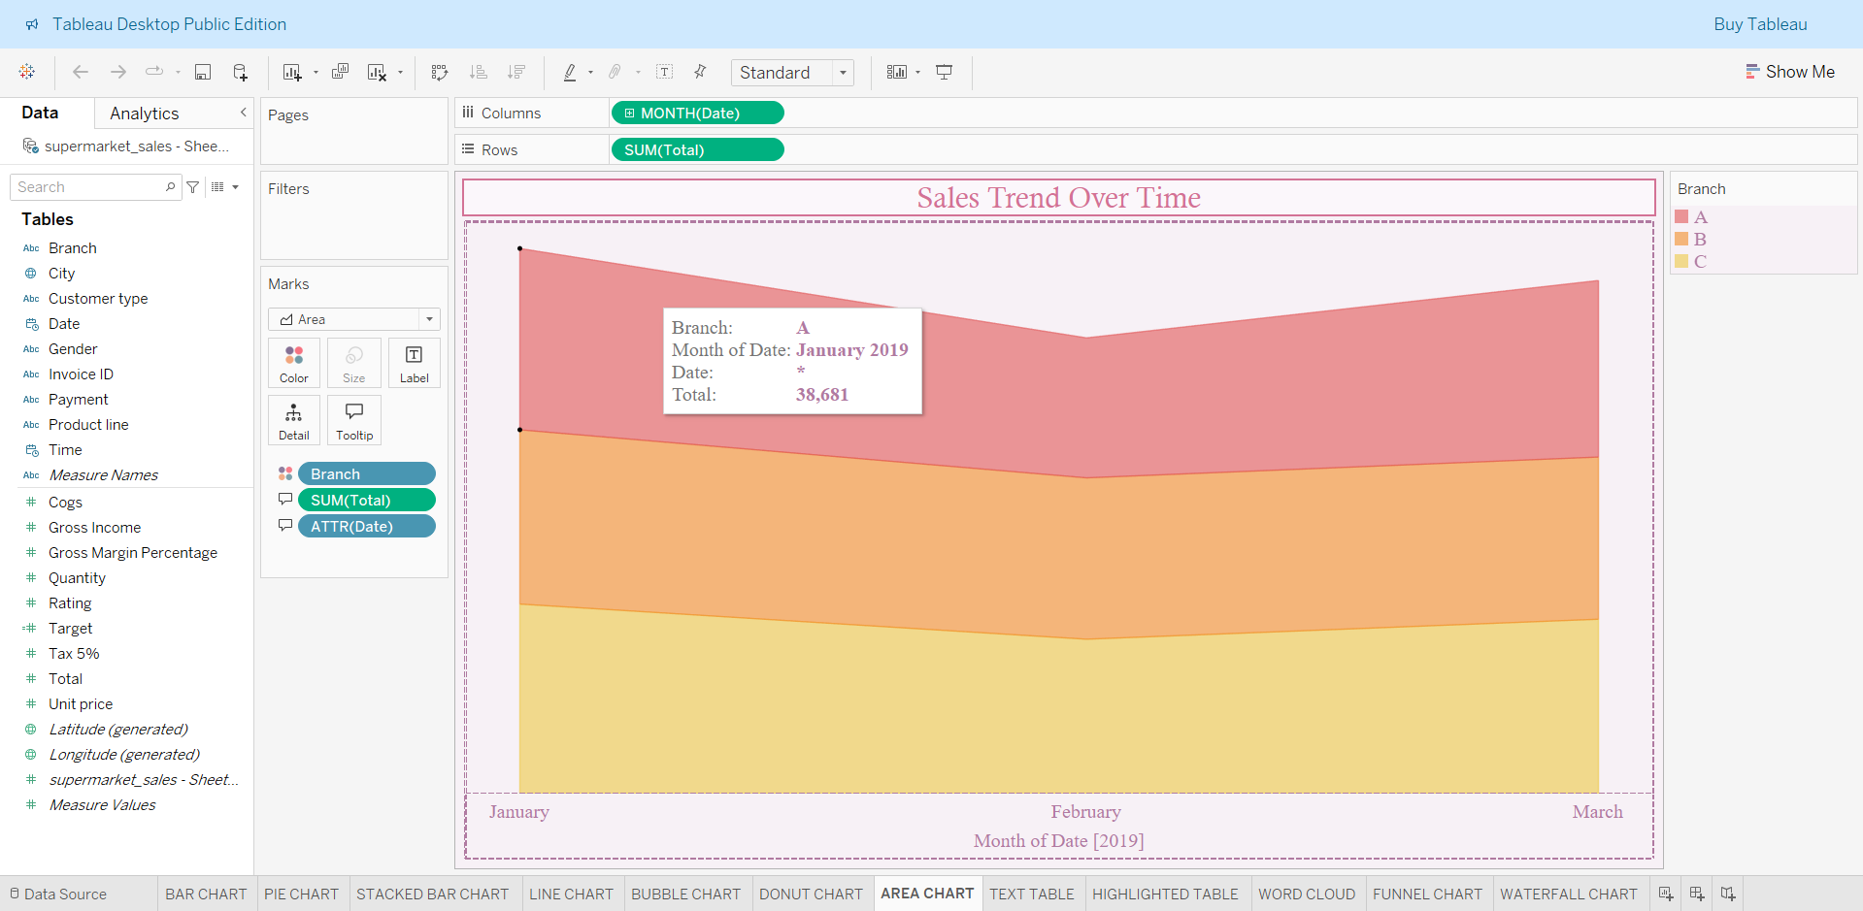

3.TEXT TABLE

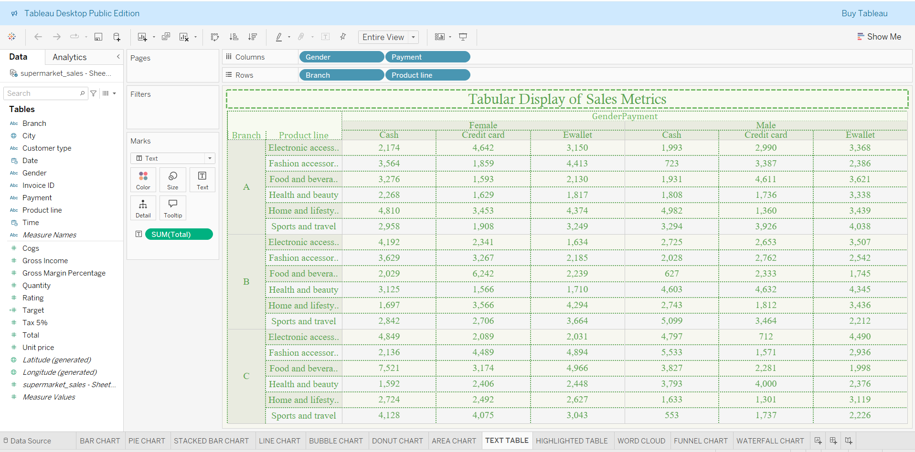

4.HIGHLIGHTED TABLE

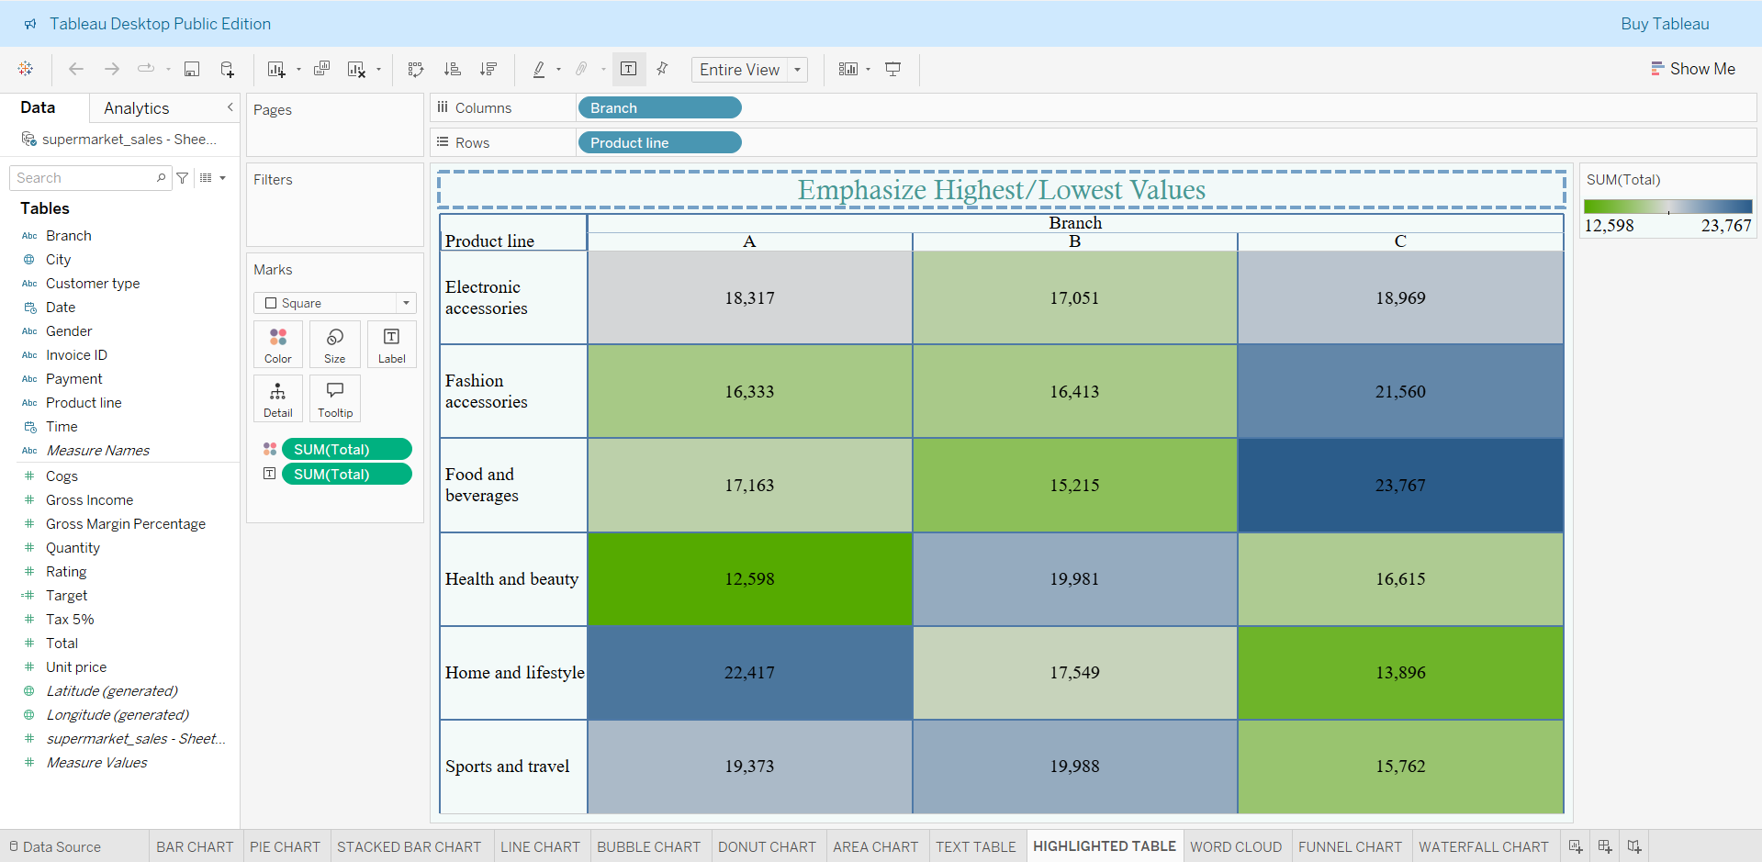

5.WORD CLOUD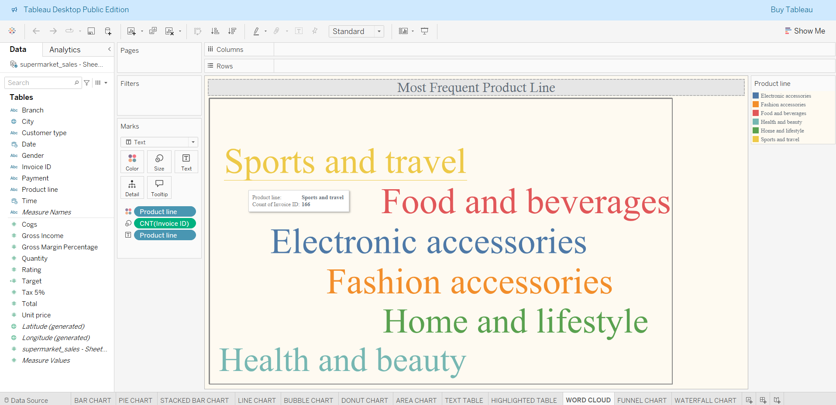

6.FUNNEL CHART

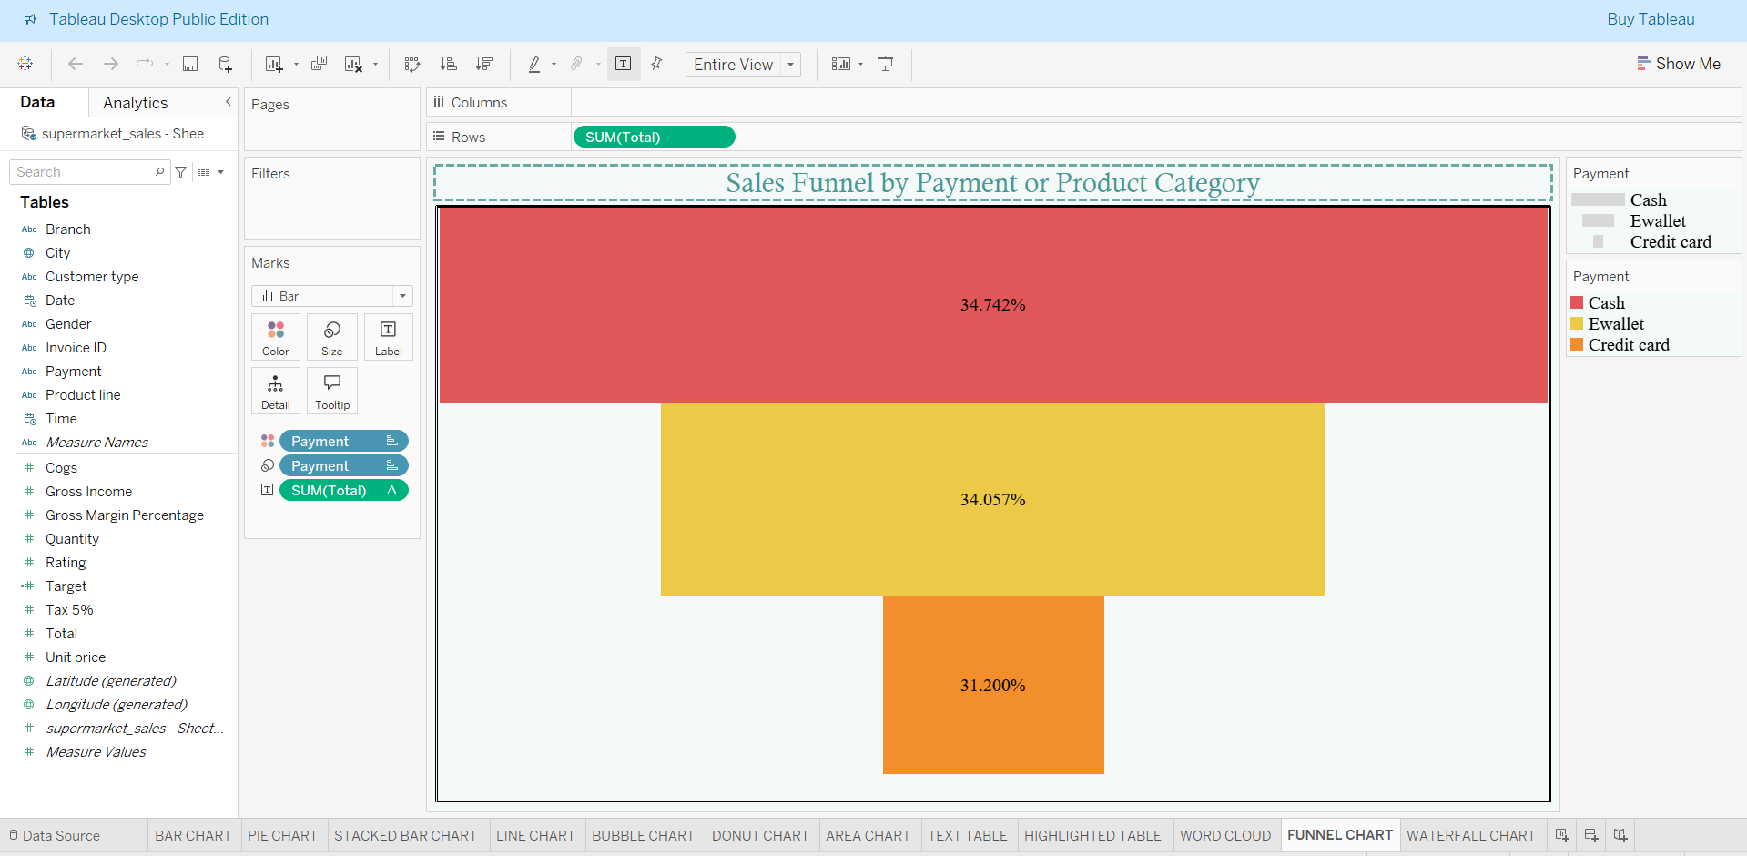

7.WATERFALL

